Launch Cloudant DB:

TEAM ID : PNT2022TMID41426

Step 1:

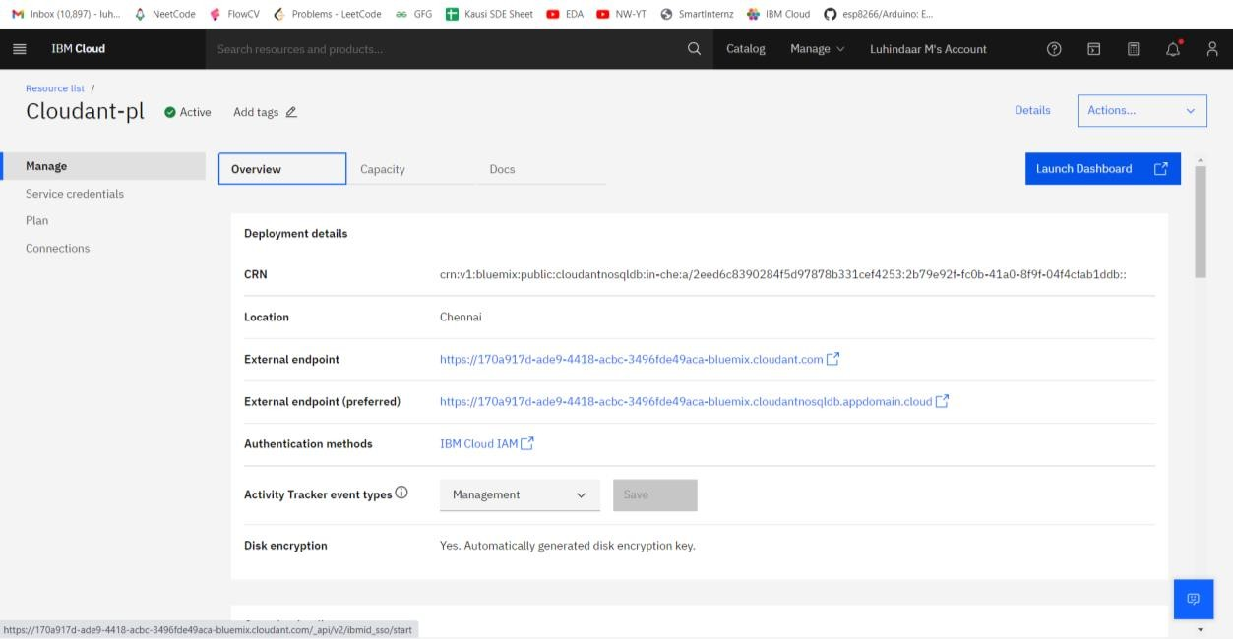

Step 2(Cloudant DB Launched):

